Course Name: | Web Development Laboratory | Semester: | III
Date of Performance: | __29_ / __7_ / ___2026___ | DIV/ Batch No: | B-2
Student Name: | Swarangi Limaye | Roll No: | 16010125120
Experiment No: 1

Title
Design and Development of an AI-based Smart Irrigation Advisory Web Portal Front-End using HTML5

Aim of the Experiment

To design and develop a multi-page, use-case-based web portal front-end using HTML5 for an AI-based Smart Irrigation Advisory System for Sugarcane Crop (KJS-AGR-01), demonstrating proper HTML5 document structure, semantic elements, formatting, lists, hyperlinks, images, image maps, tables, forms, and multimedia elements.

Objectives of the Experiment
- To develop structured and semantic HTML5 web pages for an AI-enabled smart irrigation advisory system.
- To create interactive web pages for farmer registration, irrigation recommendations, weather information, crop monitoring, and advisory services.
- To apply a real-world AI and IoT-based agriculture use case (Smart Irrigation Advisory System) as the context for front-end web development.
- To build a complete HTML5 front-end portal that can later be enhanced using CSS3, JavaScript, PHP, and React.

COs to be achieved
CO1: Developing webpages using HTML and CSS.

Books / Journals / Websites references
- (Students should write — e.g., MDN Web Docs HTML5 reference, W3C.)

Theory

HTML5 is the latest version of HyperText Markup Language used to create structured and interactive web pages. It introduces semantic elements such as <header>, <nav>, <main>, <section>, <article>, and <footer>, making web pages more organized, accessible, and search-engine friendly.

HTML5 also provides support for multimedia elements like <audio> and <video>, interactive forms, tables, hyperlinks, image maps, and embedded content through <iframe>. These features help developers create user-friendly web applications for various domains such as healthcare, education, business, and agriculture.

In this experiment, HTML5 is used to design the front-end of an AI-based Smart Irrigation Advisory System. The portal enables farmers to register their farms, view irrigation schedules, monitor weather conditions, access crop information, receive AI-generated irrigation recommendations, and visualize farm locations. The application serves farmers, agricultural officers, researchers, and sugar factory management by providing organized and easy-to-understand agricultural information.

Problem Statement

"AI-based Smart Irrigation Advisory Web Portal"
An agricultural organization wants to develop a basic HTML5-based web portal front-end for an AI-based Smart Irrigation Advisory System. The portal should display farm information, soil moisture status, weather forecasts, irrigation recommendations, crop information, and advisory services for farmers, agricultural officers, researchers, and sugar factory management.
Each task below contributes one page or feature of this portal, representing different modules of the Smart Irrigation Advisory System.

Task 1: Home Page – HTML5 Document Structure & Global Attributes

Use Case

Design the Home Page of the Smart Irrigation Advisory Portal.

Requirements

Use proper HTML5 document structure.

Display the system name "Smart Irrigation Advisory System".

Display organization name and agriculture logo text.

Show the current crop season and year.

Apply global attributes such as id, class, title, and style.

Add a tooltip explaining the purpose of the system.

Deliverable: index.html

Skills Tested: HTML document structure, global attributes.

Task 2: Irrigation Advisory Page – Formatting & Text-Level Tags

Use Case

Create a page describing the AI-based Irrigation Advisory System.

Requirements

Highlight important irrigation recommendations using <strong> and <mark>.

Use <em> to emphasize water conservation practices.

Use <small> for advisory notes and disclaimers.

Use <sup> and <sub> for units such as m³, cm³, H₂O, and temperature values.

Use <abbr> for agricultural abbreviations such as AI, IoT, GIS, GPS, and ET.

Deliverable: irrigation-advisory.html

Skills Tested: Formatting and text-level HTML tags.

Task 3: About System Page – Block & Inline Formatting

Use Case

Design an About the Smart Irrigation Advisory System page.

Requirements

Create separate <div> sections for:

Objectives

System Features

Benefits

Use <blockquote> to display a message from an Agricultural Expert.

Apply inline formatting within paragraphs.

Use different background colours for different sections.

Deliverable: about-system.html

Skills Tested: Block-level and inline elements.

Task 4: Farm Information & Sensors Page – Lists & Nested Lists

Use Case

Display agricultural resources and stakeholder information.

Requirements

Create an ordered list showing the irrigation advisory workflow.

Create an unordered list of data sources:

Soil Moisture Sensors

Weather Forecast

Satellite Images

Crop Information

Soil Reports

IoT Devices

Create nested lists showing stakeholders and their responsibilities:

Farmer

Agricultural Officer

Researcher

Sugar Factory Management

Create a description list explaining abbreviations such as AI, IoT, GIS, GPS, and ET.

Deliverable: farm-information.html

Skills Tested: Lists and nested lists.

Task 5: Navigation Page – Hyperlinks

Use Case

Create the navigation menu for the Smart Irrigation Advisory Portal.

Requirements

Link all internal web pages.

Add an external link to the KIAAR or Agricultural Department website.

Create an email link for agricultural support.

Add a telephone link for farmer helpline services.

Deliverable: navigation.html

Skills Tested: Hyperlinks.

Task 6: Farm Location Page – Images & Image Maps

Use Case

Provide an interactive map of agricultural fields.

Requirements

Display a farm or geofenced plot map image.

Create an image map with clickable farm regions.

Each region should open a page displaying crop details or irrigation information.

Add alternate text for accessibility.

Deliverable: farm-map.html

Skills Tested: Images and image maps.

Task 7: Irrigation Recommendation Page – Tables

Use Case

Display plot-wise irrigation recommendations.

Requirements

Create a table showing:

Plot ID

Farmer Name

Crop Stage

Soil Moisture (%)

Recommended Irrigation Date

Irrigation Duration

Weather Forecast

Recommendation Status

Use:

<caption>

<thead>

<tbody>

<tfoot>

rowspan

colspan

Deliverable: recommendation.html

Skills Tested: Tables.

Task 8: Farmer Registration Form – Forms

Use Case

Create an online farmer registration page.

Requirements

Include fields for:

Farmer Name

Mobile Number

Email Address

Village

Plot ID

Crop Variety

Farm Area

Irrigation Method (Dropdown)

Preferred Language (Radio Buttons)

Advisory Services Required (Checkboxes)

Submit and Reset buttons

Deliverable: farmer-registration.html

Skills Tested: HTML Forms.

Task 9: Media & Awareness Page – Multimedia

Use Case

Create an Agriculture Awareness page.

Requirements

Embed an irrigation awareness video using <video>.

Add an audio advisory on water conservation using <audio>.

Embed the farm location or Google Map using <iframe>.

Display a <noscript> message for users with JavaScript disabled.

Deliverable: media.html

Skills Tested: Multimedia, frames, and executable content.
Code :
Index.html
<!DOCTYPE html>
<html lang="en">

<head>
<title>Smart Irrigation Advisory System</title>

</head>

<body>

<header id="header" class="main-header"
style="background-color:#355E3B; padding:15px; display: flex; align-items: center; gap: 20px;">

<a href="index.html" style="text-decoration: none; flex-shrink: 0;">
<img src="logo.png" alt="Smart Irrigation Logo" style="height: 150px; width: auto; display:inline;">
</a>

<div style="display: flex; flex-direction: column; justify-content: center;">
<h2 title="Agriculture Organization" style="color: #ECFFDC; margin: 0 0 5px 0; font-size: 1.2rem;">
KJSSE | KIAAR | Godavari Biorefineries
</h2>

<h1 id="systemName" class="title" title="AI-powered Smart Irrigation Advisory System for Sugarcane Farmers"
style="color: #C1E1C1; margin: 0 0 5px 0; font-size: 1.8rem;">
Smart Irrigation Advisory System
</h1>

<p style="color: #96DED1; margin: 0;">
<strong>Current Crop Season:</strong> Kharif 2026
</p>
</div>

</header>

<nav style="background-color:#f0f0f0; padding:10px;">

<a href="index.html">Home</a> |

<a href="about-system.html">About</a> |

<a href="irrigation-advisory.html">Irrigation Advisory</a> |

<a href="farm-information.html">Farm Information</a> |

<a href="farm-map.html">Farm Map</a> |

<a href="recommendation.html">Recommendations</a> |

<a href="farmer-registration.html">Farmer Registration</a> |

<a href="media.html">Media</a>

</nav>

<!-- ================= MAIN CONTENT ================= -->

<main>

<section id="welcome">

<h2 style="text-align:center; color:#40826D">_______---------- Welcome ----------________</h2>

<p title="Purpose of the Smart Irrigation Advisory System">

The Smart Irrigation Advisory System is an AI-enabled web portal that assists
sugarcane farmers in making informed irrigation decisions using soil moisture,
weather forecasts, IoT sensors, and AI-generated recommendations.

</p>

</section>

<section>

<h2>Portal Features</h2>

<ul>
<li>Farmer Registration</li>
<li>Farm Information</li>
<li>Weather Monitoring</li>
<li>AI Irrigation Recommendations</li>
<li>Crop Monitoring</li>
<li>Agricultural Awareness</li>
</ul>

</section>
<section>

<h2>Core Objectives</h2>

<ul>
<li>Optimize Water Use:Saves water by only irrigating when necessary.</li>

<li>Maximize Sugarcane Yield:Prevents root rot from over-watering and stunting from under-watering.</li>

<li>Reduce Energy Costs:Minimizes electricity bills by running water pumps efficiently.</li>

<li>Automate Manual Planning:Eliminates guesswork by replacing manual checks with data-driven
scheduling.</li>
</ul>

</section>

</main>

<!-- ================= FOOTER ================= -->

<footer style="background-color:#ECFFDC; padding:10px; text-align:center; color:#40826D;">

<p>
© 2026 Smart Irrigation Advisory System
</p>

</footer>

</body>

</html>

Fram-map.html
<!DOCTYPE html>

<head>
<title>Farm Location Map</title>
</head>

<body>

<header id="header" class="main-header"
style="background-color:#355E3B; padding:15px; display: flex; align-items: center; gap: 20px;">

<div style="display: flex; flex-direction: column; justify-content: center;">
<h1 style="color:#C1E1C1">Farm Location</h1>
<p style="color:#C1E1C1">Smart Irrigation Advisory System</p>
</div>
</header>

<nav style="background-color:#f0f0f0; padding:10px;">

<a href="index.html">Home</a> |

<a href="about-system.html">About</a> |

<a href="irrigation-advisory.html">Irrigation Advisory</a> |

<a href="farm-information.html">Farm Information</a> |

<a href="farm-map.html">Farm Map</a> |

<a href="recommendation.html">Recommendations</a> |

<a href="farmer-registration.html">Farmer Registration</a> |

<a href="media.html">Media</a>

</nav>

<hr>

<main>

<h2 style=" text-align:center;">Interactive Farm Map</h2>

<p style=" text-align:center;">
Click on any farm plot to view irrigation and crop details.
</p>

<div style="display: flex; justify-content: center;">
<img src="farm-map.jpg" alt="Interactive farm map showing four sugarcane plots" usemap="#farmmap"
width="700" height="400">
</div>

<map name="farmmap">

<!-- Plot A -->
<area shape="rect" coords="0,0,400,250" href="plot-a.html" alt="Plot A" title="Plot A">

<!-- Plot B -->
<area shape="rect" coords="0,250,266,500" href="plot-b.html" alt="Plot B" title="Plot B">

<!-- Plot C -->
<area shape="rect" coords="266,250,533,500" href="plot-c.html" alt="Plot C" title="Plot C">

<!-- Plot D -->
<area shape="rect" coords="533,250,800,500" href="plot-d.html" alt="Plot D" title="Plot D">

</map>

</main>

<hr>
<footer style="background-color:#ECFFDC; padding:10px; text-align:center; color:#40826D;">

<p>
© 2026 Smart Irrigation Advisory System
</p>

</footer>

</body>

</html>
Plot-a.html
<!DOCTYPE html>

<head>
<title>Plot A</title>
</head>

<body style = "background-color: rgb(193, 225, 193);">

<h1>Plot A Details</h1>

<ul>
<li><strong>Farmer:</strong> Ramesh</li>
<br>
<li><strong>Crop:</strong> Sugarcane</li>
<br>
<li><strong>Soil Moisture:</strong> 32%</li>
<br>
<li><strong>Recommendation:</strong> Irrigate tomorrow morning.</li>
</ul>

<a href="farm-map.html">← Back to Farm Map</a>

</body>
</html>
Plot-b.html
<!DOCTYPE html>

<head>
<title>Plot B</title>
</head>

<body style = "background-color: rgb(193, 225, 193);">

<h1>Plot B Details</h1>

<ul>
<li><strong>Farmer:</strong> Madhu </li>
<li><strong>Crop:</strong> Sugarcane</li>
<li><strong>Soil Moisture:</strong> 50%</li>
<li><strong>Recommendation:</strong> Irrigate tomorrow afternoon.</li>
</ul>

<a href="farm-map.html">← Back to Farm Map</a>

</body>
</html>
Plot-c.html
<!DOCTYPE html>

<head>
<title>Plot C</title>
</head>

<body style = "background-color: rgb(193, 225, 193);">

<h1>Plot C Details</h1>

<ul>
<li><strong>Farmer:</strong> Kushal</li>
<li><strong>Crop:</strong> Sugarcane</li>
<li><strong>Soil Moisture:</strong> 75%</li>
<li><strong>Recommendation:</strong> Irrigate tomorrow evening.</li>
</ul>

<a href="farm-map.html">← Back to Farm Map</a>

</body>
</html>

Plot-d.html
<!DOCTYPE html>

<head>
<title>Plot D</title>
</head>

<body>

<body style = "background-color: rgb(193, 225, 193);">

<ul>
<li><strong>Farmer:</strong> Raghu</li>
<li><strong>Crop:</strong> Sugarcane</li>
<li><strong>Soil Moisture:</strong> 93 %</li>
<li><strong>Recommendation:</strong> Irrigate tomorrow evening.</li>
</ul>

<a href="farm-map.html">← Back to Farm Map</a>

</body>
</html>

Output / Screenshot:
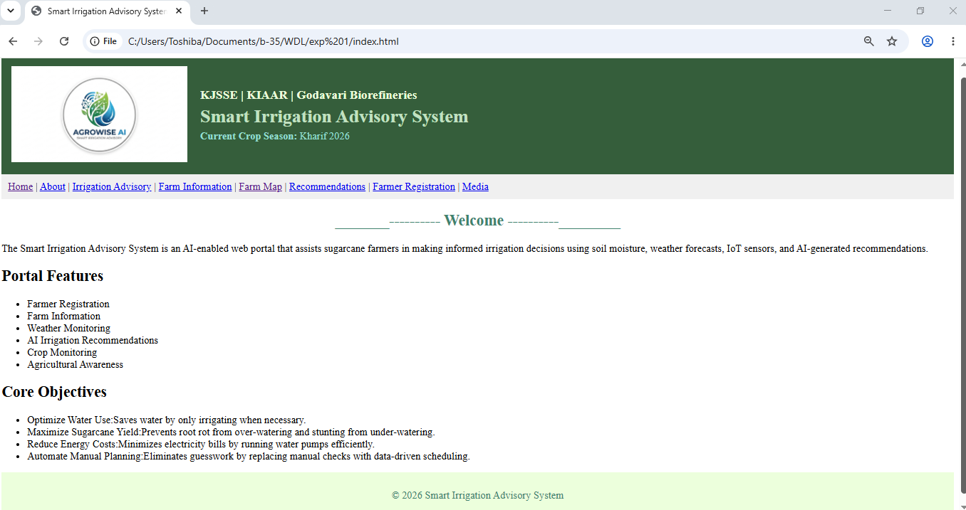

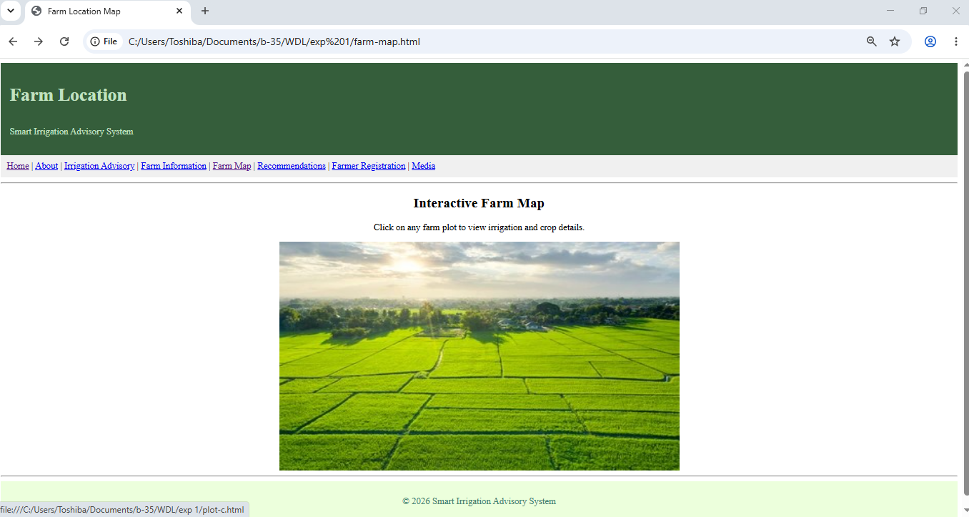

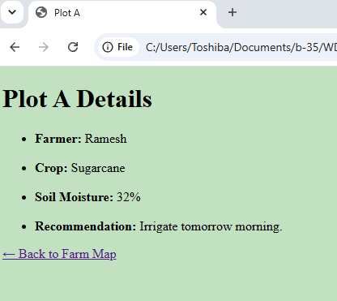
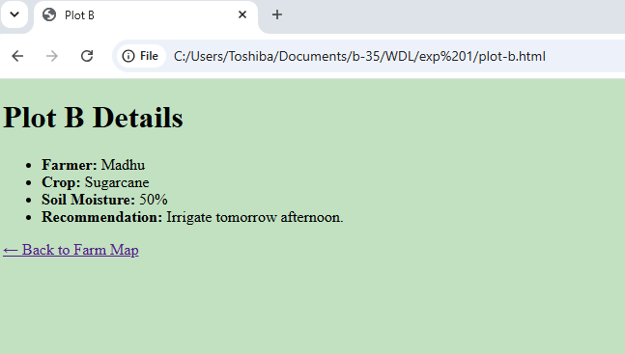
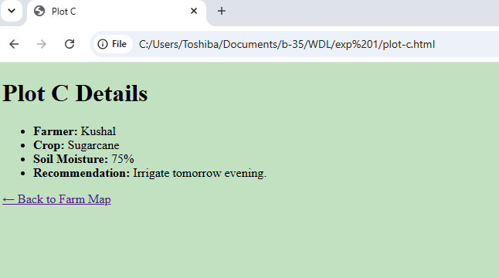

Conclusion and Discussion:
Designed and developed index.html and farm.html pages along with the four individual plot html pages using HTML5.The AI-based Irrigation Advisory System provides farmer registration, irrigation recommendations, farm information, crop monitoring, and resources.
The website is easy to navigate and all required elements have been used.

